Assignment 2

Create a new SQLFiddle and then add the database from db.sql (provided in tasks/1_introduction/day_2_basic_tooling/hands_on_sql) to be able to perform queries.
Your task then is to do two things:
1. Insert two articles written by Joe (id 3) into articles table (choosing the titles is up to you).
2. Write a query that will return you a list of articles written by authors who are at least 25 years old.

Solution (1)

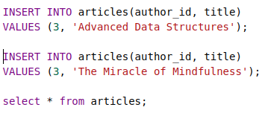

- I used the above two insert queries to insert the articles into the database against Joe.
    - Advanced Data Structures
    - The Miracle of Mindfulness
- Than use select query to show the database

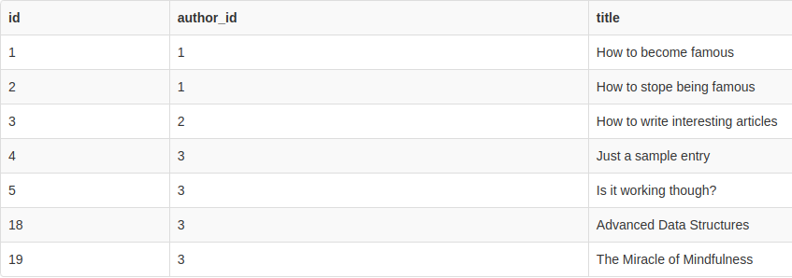
Solution (2)
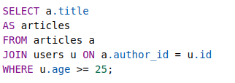

- Query lists of articles as articles written by authors who are at least 25 years old.

